ECB staff macroeconomic projections for the euro area
March 2026

Contents
1 Overview 2
2 Macroeconomic projections for the euro area economy – baseline assessment 6
2.1 Real economy 6
Box 1 International environment 11
Box 2 Technical assumptions and assumptions about tariffs 12
2.2 Prices and costs 14
Box 3 Fiscal outlook 21
3 Alternative scenarios for the economic implications of the war in the Middle East 23
3.1 Overview of the alternative scenario narratives 23
3.2 Key assumptions underlying the alternative scenarios 25
3.3 The impact on the global economy across scenarios 28
3.4 The impact on the euro area economy across scenarios 29
3.5 Caveats to the scenario analysis 33
4 Sensitivity analyses 34
4.1 Alternative energy price paths 34
4.2 Alternative exchange rate paths 36

Overview
The euro area economy remained resilient in 2025, despite uncertainty and trade policy shocks. Growth expectations were consistently revised up over the course of last year and the economy broadly maintained this positive momentum into the start of 2026. However, the war in the Middle East has brought renewed uncertainty and the economic outlook is clouded again. Disruptions to shipping through the Strait of Hormuz, a key route for global oil and liquefied natural gas (LNG) trade, together with attacks on energy infrastructure, have led to significant volatility in global energy markets and have pushed up oil and gas prices. The baseline staff projections are conditioned on the paths of futures prices for energy commodities at the time of the cut-off date of 11 March 2026. These suggest quarterly average oil and gas prices will peak at around USD 90 per barrel and €50 per MWh respectively in the second quarter of 2026 and will then decline over the following quarters. In line with these assumptions, the baseline foresees a pick-up in inflation, which will dampen purchasing power, consumer spending and, hence, GDP growth, especially in the short term. Nevertheless, the future evolution of the conflict, its impact on energy prices, uncertainty and confidence, and the pass-through of the energy price shock to non-energy consumer prices remain highly uncertain. Therefore, the baseline projections are complemented by alternative, hypothetical scenarios which assume varying degrees of severity of the economic impact of the conflict on the euro area.
The euro area economy grew by 0.2% at the end of last year, in line with the December staff projections, and was supported by strengthening consumption and government investment. Short-term indicators suggested positive growth dynamics continued in the first two months of 2026, but the war in the Middle East has resulted in a downward revision to the short-term outlook for growth, as the shocks to energy prices and increase in uncertainty will likely lead to more subdued consumption and investment. Conditional on a relatively rapid reduction in energy prices, as is priced in by the energy commodity futures markets, and in uncertainty, this slowdown is expected to be temporary. Over the medium term, domestic demand should remain the main driver of euro area growth, bolstered by a resilient labour market and government spending on infrastructure and defence, especially in Germany. On the external side, while export growth is expected to pick up on the back of improving foreign demand, the euro area will likely experience a continued loss of global market shares, given persistent competitiveness challenges, including some that are of a structural nature, and notwithstanding the fact that tariffs on exports to the United States are somewhat lower than at the time of the December projections. The baseline projections foresee annual real GDP growth of 0.9% in 2026, 1.3% in 2027 and 1.4% in 2028. Compared with the December 2025 projections, GDP growth has been revised down by 0.3 percentage points for 2026 and by 0.1 percentage points for 2027, on account of the escalating war in the Middle East, while for 2028 it is unchanged.
Inflation, as measured by the Harmonised Index of Consumer Prices (HICP), is projected to increase sharply to 3.1% in the second quarter of 2026, driven by a surge in energy inflation as a result of the Middle East crisis, and then to decline in the third quarter to 2.8% following declines in energy commodity prices as embedded in futures prices. The baseline projections foresee energy inflation turning negative in 2027, mainly owing to downward energy base effects, and then increasing notably in 2028 when the implementation of the EU Emissions Trading System 2 (ETS2) is expected to have an upward impact of 0.2 percentage points on headline inflation. Food inflation is projected to pick up from the end of 2026, as cost pressures from the spike in energy prices feed through to consumer food prices, before easing in 2028. HICP inflation excluding energy and food (HICPX) is projected to moderate from 2.4% in 2025 to stand at 2.1% in 2028. While HICPX inflation is also affected by cost pressures stemming from higher energy prices, this is seen to be tempered by some easing in labour cost pressures, the past appreciation of the euro and import penetration from China. Overall, the baseline projections foresee HICP inflation picking up from 2.1% in 2025 to 2.6% in 2026, before declining to 2.0% in 2027 and then ticking up to 2.1% in 2028. Wage growth will moderate over the coming years, albeit at a slower pace than foreseen in previous projections on account of some inflation compensation effects related to the energy price shock. Compared with the December 2025 projections, the outlook for headline HICP inflation has been revised up by 0.7 percentage points for 2026, mainly owing to the energy component. It has been revised up by 0.2 percentage points for 2027 and by 0.1 percentage points for 2028 as cost pressures stemming from higher energy prices feed through to the HICPX and food components, while the energy component has been revised down somewhat.
In addition to the baseline projections, staff have prepared alternative, hypothetical scenarios which differ in terms of the assumptions about the magnitude and persistence of the energy price shock, its impact on the international environment and uncertainty, and its propagation via indirect and second-round effects on inflation. These scenarios offer illustrative examples of alternative paths for energy commodity prices and their transmission to the euro area economy. The staff do not assign any probabilities to these scenarios – they serve rather to highlight the key uncertainties regarding the impact of the conflict. As is the usual convention in the staff projections, these scenarios illustrate the impacts on the euro area economy in the absence of any monetary or fiscal policy reaction beyond what is included in the baseline. The adverse scenario incorporates stronger indirect and second-round effects than the baseline, with a view to capturing possible non-linearities in the propagation of the initial energy price shock to other prices across the economy. It assumes a much sharper increase in energy prices, as well as an increase in uncertainty and in adverse international spillovers (for example, reduced foreign demand). Oil and gas prices are assumed to peak at USD 119 per barrel and €87 per MWh respectively in the second quarter of 2026, before converging to the baseline assumptions by the third quarter of 2027. Relative to the baseline, the adverse scenario implies that inflation would be 0.9 percentage points and 0.1 percentage points higher in 2026 and 2027 respectively, but 0.5 percentage points lower in 2028 owing to the disinflationary pressures stemming from the rapid normalisation of energy prices in that year. Conversely, economic growth would be lower than in the baseline in 2026 and 2027, but higher in 2028. Compared with the adverse scenario, the severe scenario assumes a stronger and more persistent energy price shock, greater uncertainty, and even stronger indirect and second-round effects. Oil prices are assumed to peak at USD 145 per barrel and gas prices at €106 per MWh in the second quarter of 2026, before declining at a much slower pace and remaining significantly above both the baseline and adverse scenario assumptions over the rest of the projection horizon. Relative to the baseline, headline inflation would be significantly and persistently higher over the projection horizon (by 1.8 percentage points in 2026, 2.8 percentage points in 2027 and 0.7 percentage points in 2028). The significant difference in inflation in 2028 between the adverse scenario (1.6%) and the severe scenario (2.8%), as shown in Table 1, highlights the key role of the evolution of the conflict, the disruptions to energy supply and the size of the propagation mechanisms triggered by the shock in determining the impact on inflation over the medium term. Economic growth would be 0.4-0.5 percentage points lower in 2026-27 and would then rise to 0.5 percentage points above the baseline in 2028. The increase in growth towards the end of the projection horizon reflects the assumed rise in income and demand resulting from the upward response of wages following the rise in inflation in the preceding years.
Finally, a set of projections based on technical assumptions with a cut-off date of 4 March (incorporating information from the first three working days after the start of the war in the Middle East) reflect a more benign outlook, with oil and gas prices assumed to peak at USD 79 per barrel and €48 per MWh respectively in the second quarter of 2026. In line with those projections, inflation would be 0.3 percentage points below the final baseline in 2026 and 0.1 percentage points below in 2027 and 2028, while growth would be 0.1 percentage points higher in each year of the projection horizon.

Table 1
Growth and inflation projections for the euro area
(annual percentage changes)
 |  | December 2025 baseline | March 2026 – baseline projections and alternative scenarios
 |  | December 2025 baseline | Baseline | Adverse scenario | Severe scenario | Projections with cut-off date of  4 March
Real GDP | 2025 | 1.4 | 1.5 | 1.5 | 1.5 | 1.5
Real GDP | 2026 | 1.2 | 0.9 | 0.6 | 0.4 | 1.0
Real GDP | 2027 | 1.4 | 1.3 | 1.2 | 0.9 | 1.4
Real GDP | 2028 | 1.4 | 1.4 | 1.6 | 1.9 | 1.5
HICP | 2025 | 2.1 | 2.1 | 2.1 | 2.1 | 2.1
HICP | 2026 | 1.9 | 2.6 | 3.5 | 4.4 | 2.3
HICP | 2027 | 1.8 | 2.0 | 2.1 | 4.8 | 1.9
HICP | 2028 | 2.0 | 2.1 | 1.6 | 2.8 | 2.0
HICP excluding energy and food | 2025 | 2.4 | 2.4 | 2.4 | 2.4 | 2.4
HICP excluding energy and food | 2026 | 2.2 | 2.3 | 2.4 | 2.6 | 2.2
HICP excluding energy and food | 2027 | 1.9 | 2.2 | 2.7 | 3.9 | 2.0
HICP excluding energy and food | 2028 | 2.0 | 2.1 | 2.1 | 2.9 | 2.1
Notes: Real GDP figures refer to annual averages of seasonally and working day-adjusted data. Historical data may differ from the latest Eurostat publications owing to data releases after the cut-off date for the projections. Data for the baseline projections are available for downloading, also at quarterly frequency, from the Macroeconomic Projection Database on the ECB’s website.

Macroeconomic projections for the euro area economy – baseline assessment

Real economy
Euro area economic activity rose by 0.2% in the fourth quarter of 2025, in line with the December projections (Chart 1). All large euro area economies posted positive growth in the fourth quarter of 2025. However, a strong contraction in Ireland – linked to the activities of multi-national enterprises – weighed on aggregate growth in the euro area as a whole. An adjusted measure of euro area GDP, which uses “modified domestic demand” instead of GDP for Ireland, rose by 0.4% in the last quarter of 2025, 0.1 percentage points more than expected in the December projections. Growth in gross value added was driven by services, such as information and communication, real estate and public services, whereas manufacturing contracted again. Private consumption and government and housing investment were somewhat stronger than expected, while trade flows were weaker.
Economic growth maintained its momentum in the first two months of 2026, as implied by survey data to February, i.e. before the start of the war in the Middle East in March. The composite output Purchasing Managers’ Index (PMI) increased to 51.9 in February, driven by the manufacturing output component, which rose by 1.4 points to 51.9, while the PMI for services business activity also ticked up to 51.9. The European Commission’s Economic Sentiment Indicator edged down in February but remained above its end-2025 level, thus pointing to ongoing growth, amid increased retail and consumer confidence.
However, the war in the Middle East has triggered a downward revision to the short-term growth outlook, as the shock to energy prices and rising uncertainty are likely to hit households’ purchasing power and consumer and business confidence. The technical assumptions conditioning the projections reflect the expectation of a relatively contained conflict in the Middle East and imply that the adverse impact would be concentrated in the short term. These assumptions are subject to very high uncertainty and warrant an enhanced focus on alternative scenarios (see Section 3). The current baseline projections entail more subdued consumption and investment dynamics than previously expected for the second and third quarters of 2026. Nevertheless, rising real incomes, against a backdrop of resilient labour markets, and increasing fiscal stimulus should continue to support growth. Quarterly growth is seen to drop from 0.3% in the first quarter, which is expected to remain relatively unaffected by the war, to stand at 0.1% in the second quarter and 0.2% in the third quarter (Chart 1, panel a). Relative to the December staff projections, this implies a downward revision of 0.3 percentage points for the second quarter and one of 0.2 percentage points for the third quarter.
Chart 1
Euro area real GDP
a) Real GDP growth | b) Real GDP levels
(quarter-on-quarter percentage changes, seasonally and working day-adjusted quarterly data) | (chain-linked volumes in EUR billions)
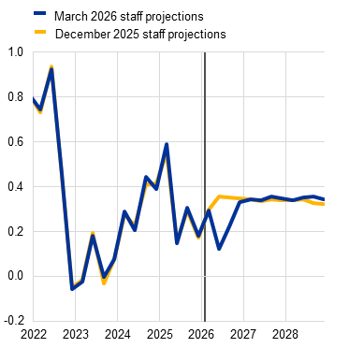 | 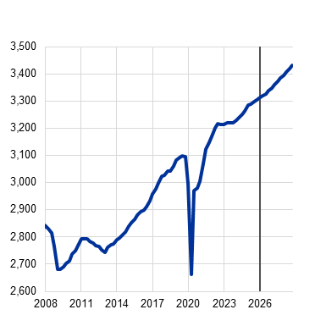
Notes: Historical data may differ from the latest Eurostat publications. The vertical line indicates the start of the current projection horizon. This chart does not show uncertainty bands around the projections. This reflects the fact that the standard computation of the fan charts (based on historical projection errors) would not, in the present circumstances, provide a reliable indication of the high uncertainty surrounding the current projections. Instead, in order to better illustrate the current uncertainty, alternative scenarios which assume varying degrees of severity of the economic impact of the war in the Middle East are presented in Section 3.
Over the medium term, annual real GDP growth is projected to increase from 0.9% in 2026 to 1.3% in 2027 and 1.4% in 2028 as domestic demand recovers, on the underlying assumption embedded in energy price futures of a short-lived shock, and as the negative contribution of net exports turns marginally positive in 2027(Chart 2 and Table 2). The dip in annual growth in 2026 to 0.9%, from 1.5% in 2025, reflects both lower intra-year dynamics and a smaller carry-over effect. From an expenditure perspective, private consumption is projected to remain the largest contributor to growth, complemented by strong investment dynamics.
- Household spending is expected to be more subdued in the short term, following the onset of the war in the Middle East, but should strengthen in the medium term. The conflict is seen to dampen private consumption mainly through losses in purchasing power, higher uncertainty and expected somewhat lower employment. Nevertheless, growth in private consumption is projected to be sustained by stronger real wage growth in the medium term, following a dip due to the higher inflation in 2026, and by still resilient labour markets. The household saving ratio should decline somewhat in spite of some upward impact from the heightened uncertainty.
- Investment should outpace GDP growth over the entire projection horizon despite initially being weakened by the war. In particular, the conflict is expected to dampen private investment through heightened uncertainty and the accelerator effect from lower demand. Nevertheless, business investment is expected to compensate to a large extent for the slowdown in public investment in 2027-28 following the expiry of the Next Generation EU (NGEU) programme. It will be supported by improving domestic and foreign demand, increased defence and infrastructure spending, receding uncertainty, still supportive financing conditions and strengthening profits. Housing investment should continue to recover on account of higher incomes, amid resilient labour markets, but it is likely to grow at a more moderate pace as higher mortgage rates weigh on affordability.
- Export growth is expected to remain subdued, as persistent euro area competitiveness challenges, US tariffs and the past appreciation of the euro continue to weigh on export performance. The war in the Middle East is expected to have a relatively mild impact on export growth, which should benefit in the short run from major trading partners’ somewhat better recent economic performance as well as a moderate boost from lower tariffs (see Box 1). Even so, the euro area is expected to see further losses in its export market share. Overall, net exports are likely to make a small negative contribution to real GDP growth in 2026, before turning marginally positive in 2027 and broadly neutral in 2028.
Domestic demand is expected to be supported by the ongoing fiscal stimulus related to defence and infrastructure spending. The cumulative growth impact from the fiscal spending on defence and infrastructure, mostly accounted for by Germany and with its strongest impulse in 2026, is estimated to be 0.5 percentage points. The projections follow the usual conventions whereby only fiscal measures that have already been legislated or have been announced and are highly likely to be legislated are included. Possible future measures by governments to contain the economic impact from the crisis, such as those observed after the last energy price spike in 2022, are not included.
Chart 2
Euro area real GDP growth – decompositions
a) Intra-year growth and carry-over effects | b) Expenditure components
(annual percentage changes and percentage point contributions) | (annual percentage changes and percentage point contributions)
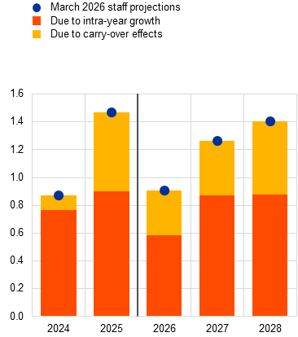 | 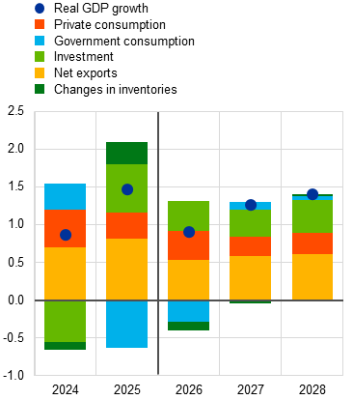
Notes: Data are seasonally and working day-adjusted. Historical data may differ from the latest Eurostat publications owing to data releases after the cut-off date for the projections. The vertical line indicates the start of the projection horizon. In panel a), carry-over effects relate to the impact on the annual average growth rate for year t due to growth up to the fourth quarter of year t-1.
Table 2
Real GDP, trade and labour market projections
(annual percentage changes, unless otherwise indicated; revisions in percentage points)
 | March 2026 |  |  |  | Revisions vs December 2025
 | 2025 | 2026 | 2027 | 2028 | 2025 | 2026 | 2027 | 2028
Real GDP | 1.5 | 0.9 | 1.3 | 1.4 | 0.1 | -0.3 | -0.1 | 0.0
Private consumption | 1.6 | 1.0 | 1.1 | 1.2 | 0.3 | -0.2 | -0.2 | 0.1
Government consumption | 1.6 | 1.8 | 1.1 | 1.3 | -0.2 | 0.3 | 0.0 | 0.1
Investment | 3.1 | 1.9 | 1.7 | 2.1 | 0.7 | -0.3 | -0.7 | -0.1
Exports1) | 2.1 | 1.2 | 2.4 | 2.8 | 0.2 | -0.4 | 0.0 | 0.2
Imports1) | 3.7 | 2.0 | 2.4 | 2.9 | 0.5 | -0.3 | -0.3 | 0.1
Contribution to GDP from:
Domestic demand | 1.8 | 1.3 | 1.2 | 1.3 | 0.2 | -0.1 | -0.2 | 0.0
Net exports | -0.6 | -0.3 | 0.1 | 0.0 | -0.1 | 0.0 | 0.1 | 0.0
Inventory changes | 0.3 | -0.1 | 0.0 | 0.0 | -0.1 | -0.1 | 0.0 | 0.0
Employment²) | 0.7 | 0.5 | 0.4 | 0.4 | 0.0 | -0.1 | -0.1 | -0.1
Unemployment rate | 6.3 | 6.3 | 6.3 | 6.2 | 0.0 | 0.1 | 0.2 | 0.3
Notes: Real GDP and components refer to seasonally and working day-adjusted data. Historical data may differ from the latest Eurostat publications owing to data releases after the cut-off date for the projections. Revisions are calculated from rounded data.
1) This includes intra-euro area trade.
2) Persons employed.
Compared with the December 2025 projections, real GDP growth has been revised down by 0.3 percentage points for 2026 and by 0.1 percentage points for 2027, and is unchanged for 2028 (Chart 3). Better than expected private consumption and investment data for 2025 were broadly offset by weaker net trade and government consumption contributions to growth, implying only a marginal upward revision to GDP growth for 2025. The war in the Middle East has led to a downward revision to average GDP growth for 2026, partly based on expert judgement accounting for the expected negative impact on consumer and business confidence from the spikes in uncertainty and financial and commodity market volatility. This revision implied a negative carry-over effect for growth in 2027 (Chart 3, panel a). The overall adverse impact of changes in assumptions for 2026-27 was partly offset by some upward effects from the fiscal impulse mostly related to somewhat less ambitious consolidation plans in one large country but also somewhat higher defence spending (see Box 3). The more supportive fiscal policies in some countries, the reduction in energy commodity prices and marginally stronger foreign demand would imply stronger growth in 2028, fully offsetting any persistent repercussions of the transitory shock to activity, resulting in no revision to growth for 2028. In terms of expenditure components (Chart 3, panel b), the downward revisions for 2026-27 refer to consumption and investment as well as changes in inventories, the latter reflecting weaker imports.
Chart 3
Revisions to real GDP growth projections compared with the December 2025 staff projections
a) Decomposition into intra-year and carry-over effects | b) Decomposition into the main expenditure components
(percentage points) | (percentage points)
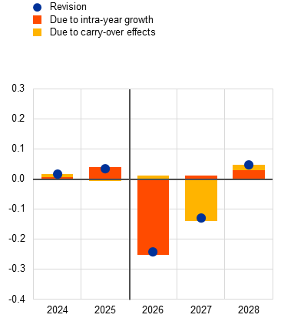 | 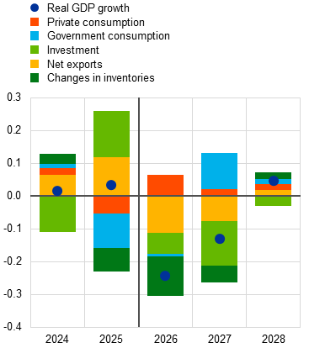
Notes: The vertical line indicates the start of the projection horizon. Revisions are calculated based on unrounded figures.
The labour market is projected to remain resilient overall, as firms are expected to hoard labour in reaction to a temporary dip in economic activity owing to the war in the Middle East. In 2025, employment growth declined following years of rather strong growth. Before the war in the Middle East, growth in employment was already projected to decline in 2026 and 2027, continuing the rebalancing phase. In the present climate, firms are largely expected to hoard labour in the short run in view of the negative shock to output emerging from the assumed transitory fallout from the war in the Middle East. However, this effect may be tempered by pressure on profits from high input costs, which would limit the scope for labour hoarding. Overall, employment growth is projected to decline more strongly in 2027 and 2028 compared with the December projections (Chart 4, panel a). This adjustment path gives rise to short-term downward revisions in labour productivity growth relative to the December projections, which are compensated for by gains in 2027 and 2028. Similarly, the unemployment rate is expected to increase slightly in 2026, followed by a decline starting in 2027, and to reach a level of 6.1% by the end of 2028 – an upward revision compared with the December projections (Chart 4, panel b).
Chart 4
Labour market
a) Employment | b) Unemployment rate
(annual percentage changes) | (percentage of labour force)
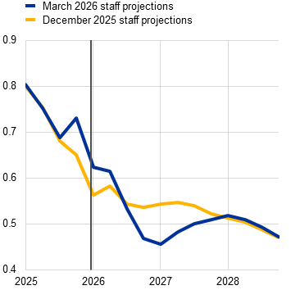 | 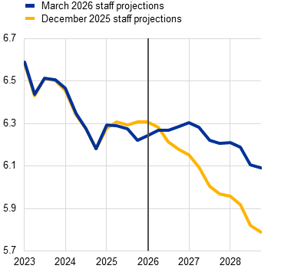
Note: The vertical line indicates the start of the current projection horizon.

Box 1
International environment
As with the euro area, the adverse effects of the war in the Middle East on the global economy are expected to be primarily driven by sharply higher energy commodity prices. These, together with tighter global financial conditions and heightened uncertainty, have dampened the outlook for the global economy, which had previously been supported by rising artificial intelligence-related investment and favourable economic policies in major economies. Additionally, lower US tariffs following a US Supreme Court decision – despite being partially offset by a temporary global tariff imposed by the US Administration (see Box 2) – are providing some support to global growth, although trade policy uncertainty remains elevated.
The conflict is estimated to reduce world real GDP growth in the baseline projections by 0.4 percentage points over the next two years, reflecting the assumed trajectory of energy commodity prices. Relative to the December projections, the war offsets the positive impact on global growth stemming from stronger than expected growth in late 2025 and the moderate boost from lower US tariffs. Overall, world real GDP growth is projected to decrease to 3.3% in 2026, down from 3.6% in 2025, and is expected to remain steady in both 2027 and 2028, broadly unchanged from the previous projections (Table A).
Table A
The international environment
(annual percentage changes, revisions in percentage points)
 | March 2026 |  |  |  | Revisions vs December 2025
 | 2025 | 2026 | 2027 | 2028 | 2025 | 2026 | 2027 | 2028
World real GDP (excluding the euro area) | 3.6 | 3.3 | 3.2 | 3.3 | 0.1 | 0.0 | -0.1 | 0.0
Global trade (excluding the euro area)1) | 5.0 | 2.3 | 2.9 | 3.2 | 0.6 | 0.3 | -0.2 | 0.1
Euro area foreign demand2) | 4.3 | 2.1 | 3.0 | 3.3 | 0.5 | 0.2 | -0.1 | 0.3
World CPI (excluding the euro area) | 3.1 | 3.1 | 2.7 | 2.5 | 0.0 | 0.3 | 0.2 | -0.1
Export prices of competitors in euro3) | -2.2 | 1.3 | 2.2 | 1.6 | -0.3 | 1.6 | 0.2 | -0.4
Note: Revisions are calculated from rounded figures.
1) Calculated as a weighted average of imports.
2) Calculated as a weighted average of imports of euro area trading partners.
3) Calculated as a weighted average of the export deflators of euro area trading partners.
Compared with the previous projection round, world headline consumer price index (CPI) inflation has been revised up for the next two years, driven by the energy price shock. For 2026, the inflationary impact of higher energy prices is partially offset by the lower than expected inflation data and the effect of lower tariffs. Global headline inflation is expected to remain at 3.1%, unchanged from last year, before declining to 2.7% in 2027 and 2.5% in 2028.
The conflict is expected to weaken euro area foreign demand and raise export prices of euro area competitors. Higher energy prices should reduce demand in the euro area’s trading partners, including for goods and services exported from the euro area. This negative impact outweighs the positive effect of slightly reduced tariffs compared with the previous projection round. However, stronger than expected data suggest slightly higher growth in euro area foreign demand this year compared with the December projections. Growth in euro area foreign demand is projected to slow sharply to 2.1% in 2026, down from 4.3% in 2025. Export prices of euro area competitors, expressed in euro, are projected to rise more sharply this year than previously projected, reflecting the combined effect of pass-through of higher global energy prices and the depreciation of the euro observed since the conflict began.

Box 2
Technical assumptions and assumptions about tariffs
Compared with the December 2025 projections, the technical assumptions entail notably higher energy commodity prices for 2026 owing to the conflict in the Middle East, but lower carbon prices and higher equity prices. Following the US-Israeli military action against Iran on 28 February and the subsequent retaliation by the Iranian regime, both oil and gas prices have surged amid considerable volatility. As a result, assumptions about prices for oil and gas for 2026 have been revised up by almost 30% and 57% respectively relative to the December 2025 projections (Chart A). However, in 2028, as the forward curve for oil and gas prices slopes strongly downwards, prices for oil and gas are expected to be, respectively, only 10% and 4% higher than in the December projections. Electricity prices are assumed to be almost 17% above the December projections in 2026 but, on average, 1.5% below in 2027 and 2028. EU Emissions Trading System 1 (ETS1) prices have been revised down, on average, by 13% over the whole projection horizon, while the price assumption for the ETS2 scheme has been kept unchanged. The euro has remained broadly unchanged since the December projections, both against the US dollar and in nominal effective terms, amid significant volatility. Market expectations for short-term interest rates have been revised up by 0.3 percentage points for 2026, by 0.5 percentage points for 2027 and by 0.3 percentage points for 2028, while long-term rates have been revised up by 0.1 percentage points throughout the projection horizon.
Chart A
Energy commodity prices
a) Oil price | b) Natural gas and wholesale electricity prices
(USD/barrel) | (EUR/MWh)
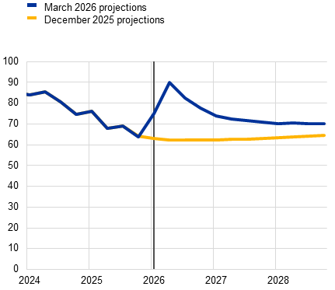 | 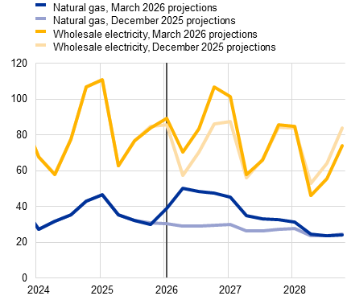
Note: The vertical line indicates the start of the projection horizon.
Following a ruling of the US Supreme Court, the effective tariff rates applied by the United States on imports, including those from the euro area, have decreased compared with the previous projections. Given that the tariffs previously imposed by the US Administration under the International Emergency Economic Powers Act were ruled as unconstitutional, a temporary “global” 10% flat tariff on US imports has been introduced with exemptions similar to those that previously applied. This tariff applies regardless of existing trade deals with the United States and is assumed to remain unchanged over the projection horizon. The new global tariff implies a reduction in the US effective tariff rate on euro area imports from 12.1% to 10.5% compared with the December projections. As the changes imply larger tariff reductions for other US trading partners, in particular China, Brazil and India, the impact on the overall US effective tariff rate is larger (4.4 percentage points lower than in the December projections) and the rate is now estimated to stand at 13.7%. Euro area exporters have, to some extent, therefore lost competitiveness in the US market relative to exporters from third countries that benefit from a larger fall in tariff rates.
Table A
Technical assumptions
 | March 2026 |  |  |  |  | Revisions vs December 2025
 | 2024 | 2025 | 2026 | 2027 | 2028 | 2025 | 2026 | 2027 | 2028
Commodities:
Oil price (USD/barrel) | 81.2 | 69.1 | 81.3 | 72.1 | 70.2 | -0.1 | 30.1 | 15.2 | 9.7
Natural gas prices (EUR/MWh) | 34.4 | 36.2 | 46.4 | 36.6 | 26.1 | -0.7 | 56.6 | 33.1 | 4.2
Wholesale electricity prices (EUR/MWh) | 77.7 | 83.6 | 87.7 | 77.9 | 65.2 | -0.4 | 16.8 | 5.7 | -8.7
EU Emissions Trading System 1 (ETS1) allowances (EUR/tonne of CO2) | 65.2 | 73.9 | 72.9 | 73.4 | 75.5 | 0.2 | -11.9 | -13.8 | -13.8
EU Emissions Trading System 2 (ETS2) allowances (EUR/tonne of CO2) | - | - | - | - | 46.0 | - | - | - | 0.0
Non-energy commodity prices, in USD (annual percentage change) | 9.2 | 5.8 | 0.8 | 0.5 | -0.6 | 0.1 | 0.7 | 0.0 | -0.3
Exchange rates:
USD/EUR exchange rate | 1.08 | 1.13 | 1.16 | 1.16 | 1.16 | 0.1 | 0.4 | 0.2 | 0.2
Euro nominal effective exchange rate (EER40) (Q1 1999 = 100) | 124.4 | 128.3 | 129.6 | 129.4 | 129.4 | 0.5 | -0.1 | -0.3 | -0.3
Financial assumptions:
Three-month EURIBOR (percentage per annum) | 3.6 | 2.2 | 2.3 | 2.6 | 2.6 | 0.0 | 0.3 | 0.5 | 0.3
Ten-year government bond yields (percentage per annum) | 2.9 | 3.3 | 3.3 | 3.5 | 3.7 | 0.2 | 0.1 | 0.1 | 0.1
Notes: Revisions are expressed as percentages for levels and as percentage points for growth rates and percentages per annum. Revisions for growth rates and interest rates are calculated on figures rounded to one decimal place, while revisions reported as percentage changes are calculated on unrounded figures. The technical assumptions about euro area interest rates and commodity prices are based on market expectations, with a cut-off date of 11 March 2026. Oil prices refer to Brent crude oil spot and futures prices. Gas prices refer to the Dutch TTF gas spot and futures prices. Electricity prices refer to the average wholesale spot and futures price for the five largest euro area countries. The “synthetic” future price for ETS1 allowances (EUA) is derived as the end-of-month linearly interpolated value of the two nearest European Energy Exchange EUA futures. Monthly EUA futures prices are then averaged to produce an equivalent to annual frequency. In the absence of meaningful trading of ETS2 allowances, the price assumptions were set by staff in line with the assumption of the European Commission in its Autumn 2025 Economic Forecast (see Box 2 of the December 2025 projections article). The paths of commodity prices are implied by futures markets in the three working days ending on the cut-off date. Bilateral exchange rates are assumed to remain unchanged over the projection horizon at the average levels prevailing in the three working days ending on the cut-off date. The assumptions for euro area ten-year nominal government bond yields are based on the average of countries’ ten-year bond yields, weighted by annual GDP figures. Where the necessary data exist, the country-specific ten-year nominal government bond yields are defined as the ten-year benchmark bond yields prolonged using the forward par yields derived, on the cut-off date, from the corresponding country-specific yield curves. For the other countries, the country-specific ten-year government bond yields are defined as the ten-year benchmark bond yield prolonged using a constant spread (observed on the cut-off date) over the technical euro area risk-free long-term interest rate assumption.

Prices and costs
Headline inflation is projected to increase from 2.1% in 2025 to 2.6% in 2026, reflecting the substantial increases in oil and gas wholesale prices (Chart 5 and Chart 6). In the first half of 2026 the evolution of headline inflation is seen to follow the surge in energy inflation, which is in line with futures prices but also reflects the recent rise in refining and distribution margins for transport fuels. Headline inflation is seen to increase from 2.1% in first quarter of 2026 to 3.1% in the second quarter, and then to decelerate to 2.7% in the second half of the year. Food inflation is expected to decrease further in the short term and to increase somewhat only later in the year owing to rising pipeline pressures from energy prices and other input costs. HICPX inflation is seen to stabilise around 2.3%, with indirect effects from energy inflation expected to be limited.
Chart 5
Euro area HICP inflation
(annual percentage changes)
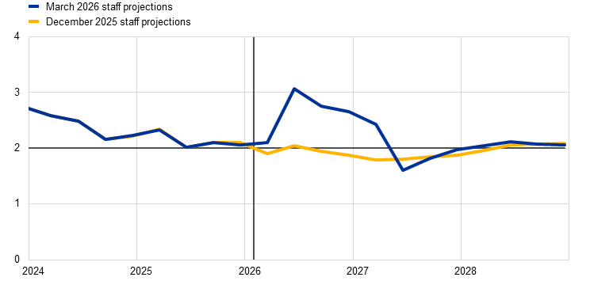
Notes: The vertical line indicates the start of the current projection horizon. This chart does not show uncertainty bands around the projections. This reflects the fact that the standard computation of the fan charts (based on historical projection errors) would not, in the present circumstances, provide a reliable indication of the high uncertainty surrounding the current projections. Instead, in order to better illustrate the current uncertainty, alternative scenarios which assume varying degrees of severity of the economic impact of the war in the Middle East are presented in Section 3.
Chart 6
Euro area HICP inflation – decomposition into the main components
(annual percentage changes, percentage points)
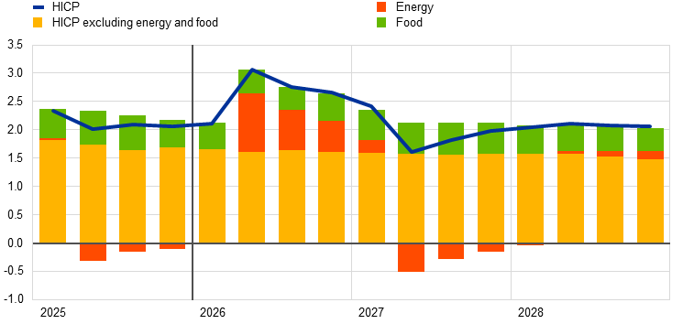
Note: The vertical line indicates the start of the current projection horizon.
In 2027 HICP inflation is expected to decrease to 2.0%, mainly owing to a fall in energy inflation, before rising to 2.1% in 2028 largely related to a pick-up in energy inflation driven by carbon prices (Chart 7, panel b). The decline in headline inflation in 2027 mainly reflects downward base effects and falling energy prices in line with a declining profile of wholesale oil and gas futures (see Box 2), with energy inflation pushed back into negative territory as of the second quarter (Chart 7, panel a). HICPX inflation is seen to moderate slightly, while food inflation increases further. The rise in headline inflation to 2.1% in 2028 is mainly attributed to a significant increase in energy inflation, driven by climate transition-related fiscal measures and, in particular, the introduction of ETS2, which is seen to push headline inflation up by 0.2 percentage points.
Food inflation is projected to decline in the short term, before increasing owing to the lagged pass-through of energy prices and then moderating in 2028 (Chart 7, panel b). It is expected to fall from 2.5% in the first quarter of 2026 to 2.1% in the third quarter, mainly driven by developments in the unprocessed food component. This decline also reflects the recent easing in prices of certain food commodities, such as sugar, cocoa and coffee. Food inflation is subsequently projected to rise to around 2.6% at the end of 2026 and to increase further to 2.9% in 2027 owing to the delayed pass-through of higher energy prices. In 2028 food inflation is expected to decline to 2.3%, reflecting declining commodity prices and easing wage pressures.
Chart 7
Outlook for HICP energy and food inflation
a) HICP energy
(annual percentage changes)
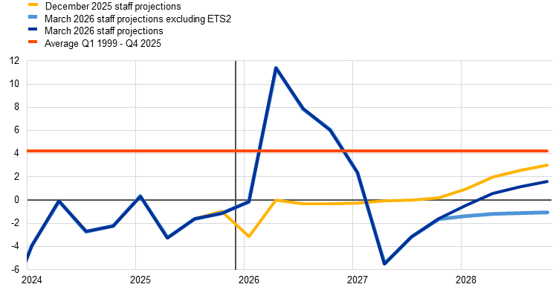
b) HICP food
(annual percentage changes)
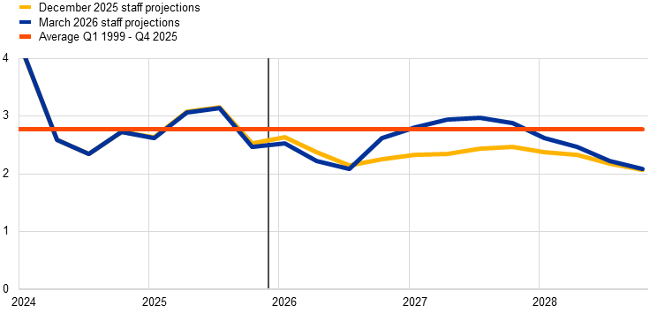
Note: The vertical line indicates the start of the current projection horizon.
HICPX inflation is expected to remain somewhat more persistent but to nevertheless moderate by 0.1 percentage points in each year of the horizon, falling from 2.4% in 2025 to 2.1% in 2028 (Chart 8). While HICPX inflation is also affected by cost pressures from higher energy prices, this is seen to be tempered by somewhat lower labour cost pressures, the past appreciation of the euro and import penetration from China. HICPX inflation is projected to be 2.3% in the first quarter of 2026 and to decline only very gradually to 2.1% by the end of the horizon. Services inflation is expected to be pushed up by some energy-related cost pressures – in particular affecting transport services – although this will be tempered by a gradually easing of labour costs. Non-energy industrial goods inflation is expected to hover around current levels in the short term, reflecting the dampening effects of the past appreciation of the euro and import penetration from China, despite being partially offset by higher energy input cost pressures.
Chart 8
Euro area HICP inflation excluding energy and food
(annual percentage changes)
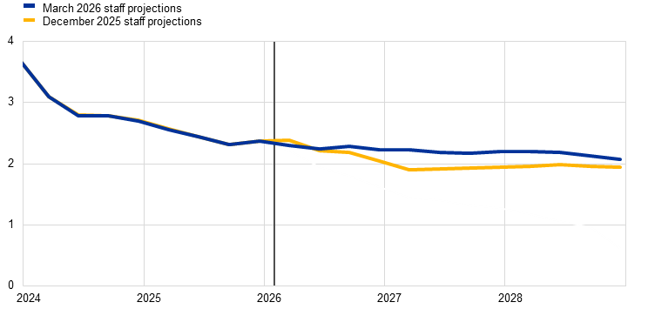
Notes: The vertical line indicates the start of the current projection horizon. This chart does not show uncertainty bands around the projections. This reflects the fact that the standard computation of the fan charts (based on historical projection errors) would not, in the present circumstances, provide a reliable indication of the high uncertainty surrounding the current projections. Instead, in order to better illustrate the current uncertainty, alternative scenarios which assume varying degrees of severity of the economic impact of the war in the Middle East are presented in Section 3.
Compared with the December 2025 projections, headline HICP inflation has been revised up by 0.7 percentage points for 2026 mainly owing to energy inflation, with much smaller upward revisions for 2027 and 2028 owing to the non-energy components (Chart 9). The upward revision to headline inflation in 2026 is mainly due to a strong upward revision to energy inflation in line with the assumptions. Energy inflation has been revised down throughout the rest of the projection horizon as a result of the rapid unwinding of the short-term spike in oil and wholesale gas price assumptions (see Box 2). The upward revision to headline inflation in 2027 and 2028 reflects the delayed pass-through of higher cost pressures from higher energy prices to the HICPX and food components. The upward revisions to food and HICPX inflation in part reflect a limited upward adjustment based on staff judgement to capture stronger pass-through effects from higher energy prices, which may be underestimated slightly by the standard modelling tools in the context of large shocks to energy prices.
Chart 9
Revisions to the inflation projection compared with the December 2025 projections
(percentage points)
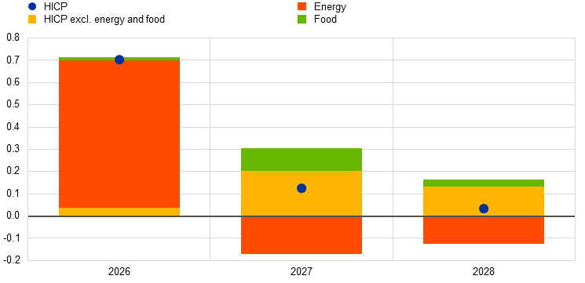
Notes: The revisions are calculated based on unrounded figures.
Table 3
Price and cost developments for the euro area
(annual percentage changes, revisions in percentage points)
 | March 2026 |  |  |  | Revisions vs December 2025
 | 2025 | 2026 | 2027 | 2028 | 2025 | 2026 | 2027 | 2028
HICP | 2.1 | 2.6 | 2.0 | 2.1 | 0.0 | 0.7 | 0.2 | 0.1
HICP excluding ETS2 | 2.1 | 2.6 | 2.0 | 1.9 | 0.0 | 0.7 | 0.2 | 0.0
HICP excluding energy | 2.5 | 2.3 | 2.4 | 2.2 | 0.0 | 0.1 | 0.4 | 0.2
HICP excluding energy and food | 2.4 | 2.3 | 2.2 | 2.1 | 0.0 | 0.1 | 0.3 | 0.1
HICP energy | -1.4 | 6.2 | -2.0 | 0.7 | 0.0 | 7.2 | -2.0 | -1.5
HICP food | 2.8 | 2.4 | 2.9 | 2.3 | 0.0 | 0.0 | 0.5 | 0.1
GDP deflator | 2.5 | 2.4 | 2.3 | 2.2 | 0.1 | 0.2 | 0.2 | 0.1
Import deflator | -0.1 | 4.3 | 1.4 | 0.9 | 0.0 | 3.6 | -0.3 | -0.9
Private consumption deflator | 2.0 | 2.8 | 2.0 | 2.1 | -0.1 | 0.8 | 0.1 | 0.0
Compensation per employee | 3.9 | 3.4 | 3.2 | 3.1 | -0.1 | 0.2 | 0.3 | 0.1
Real compensation per employee | 1.8 | 0.6 | 1.2 | 1.0 | -0.1 | -0.6 | 0.2 | 0.2
Productivity per employee | 0.7 | 0.4 | 0.9 | 1.0 | 0.0 | -0.2 | 0.0 | 0.1
Unit labour costs | 3.1 | 3.0 | 2.3 | 2.1 | -0.2 | 0.4 | 0.3 | 0.0
Notes: Revisions are calculated using figures rounded to one decimal place. The figures for the GDP and import deflators, unit labour costs, compensation per employee and productivity per employee refer to seasonally and working day-adjusted data. Historical data may differ from the latest Eurostat publications owing to data releases after the cut-off date for the projections. Data are available for downloading, also at quarterly frequency, from the Macroeconomic Projection Database on the ECB’s website.
Nominal wage growth is expected to ease further in 2026 and then move broadly sideways over the remainder of the projection horizon, albeit at a higher rate than foreseen in the December projections. According to Eurostat data, growth in compensation per employee decreased to 3.7% in the fourth quarter of 2025, compared with 3.9% foreseen in the December projections. It is expected to slow from 3.9% on average in 2025 to 3.1% in the last quarter of 2026, and then to remain broadly around this level in 2027-28 (Chart 10, panel a). Real wage growth is projected to decline in 2026 and gradually converge towards productivity growth in the latter half of the projection horizon (Chart 10, panel b). Compared with the December 2025 projections, growth in compensation per employee has been revised up over the full projection horizon reflecting some inflation compensation effects related to the energy price shock.
Chart 10
Outlook for wage developments
a) Compensation per employee
(percentage points of annual percentage changes)
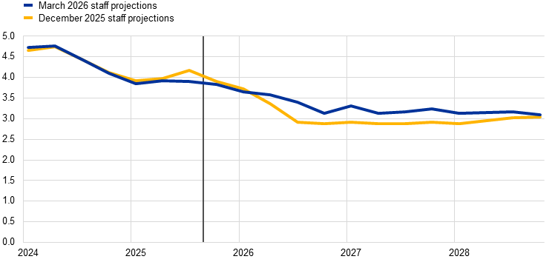
b) Real compensation per employee and productivity
(annual percentage change)
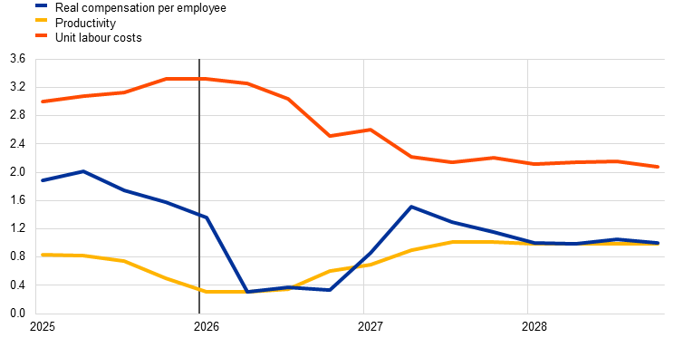
Notes: The vertical line indicates the start of the current projection horizon. In panel b), the figures are deflated by the private consumption deflator.
Growth in unit labour costs is projected to moderate only slightly in 2026, driven by lower wage growth which is partially offset by lower productivity growth, and then to decline further in 2028 as productivity growth recovers. On average, unit labour cost growth is expected to moderate from 3.1% in 2025 to 3.0% in 2026 and to 2.1% in 2028. GDP deflator growth is expected to decline from an average of 2.5% in 2025 to 2.2% in 2028 on the back of lower growth in unit labour costs. Compared with the December 2025 projections, GDP deflator growth has been revised up somewhat over the projection horizon.
While recent outturns for import prices have been dampened by the appreciation of the euro and low-cost sourcing from China, they are expected to increase sharply in the second quarter of 2026, driven by energy commodity prices. In annual terms, the growth rate of the import deflator is projected to rise from -0.1% in 2025 to 4.3% in 2026. Thereafter it is projected to decline quickly, reflecting the assumed declines in energy prices.

Box 3
Fiscal outlook
After loosening slightly in 2025, the euro area fiscal stance is projected to loosen more strongly in 2026 and to tighten somewhat over 2027-28 but the outlook is subject to uncertainty (Table A). The loosening in 2026 is mainly on account of higher public investment and fiscal transfers. The increase in investment reflects primarily high defence and infrastructure spending in Germany, alongside other smaller countries, and to some extent investment funded by the Next Generation EU (NGEU) programme. In 2027 and 2028 the tightening in the fiscal stance is explained by expected consolidation in many countries, including Italy, France and Spain, and the expiration of most of the stimulus from NGEU grants, which is largely offset by stimulus mostly in Germany. The fiscal outlook is subject to high uncertainty exacerbated by the war in the Middle East. The fiscal stance may turn more expansionary than assumed in the baseline if governments respond with energy support measures.
Compared with the December 2025 projections, the fiscal stance is expected to be somewhat looser (by about 0.2 percentage points of GDP) over 2025-28. The latest data indicate that the fiscal stance in 2025 was looser by about 0.1 percentage points of GDP compared with December. This was mainly on account of higher government investment, particularly in Germany where it was related to defence, as well as in Italy and France. The fiscal stance for 2026-28 is expected to be cumulatively about 0.1 percentage points of GDP looser. This is mostly driven by less restrictive discretionary measures in France following the recent changes to the 2026 budget. The loosening in France is partly offset by tightening in other countries, mostly stemming from less dynamic expenditure growth.
Table A
Fiscal outlook for the euro area
(percentage of GDP; revisions in percentage points)
 | March 2026 |  |  |  |  | Revisions vs December 2025
 | 2024 | 2025 | 2026 | 2027 | 2028 | 2025 | 2026 | 2027 | 2028
Fiscal stance1) | 0.9 | -0.1 | -0.3 | 0.2 | 0.2 | -0.1 | 0.0 | 0.0 | 0.0
General government budget balance | -3.1 | -3.1 | -3.4 | -3.6 | -3.6 | -0.1 | -0.1 | -0.2 | -0.2
Structural budget balance2) | -3.0 | -3.1 | -3.4 | -3.7 | -3.7 | -0.1 | -0.1 | -0.2 | -0.2
General government gross debt | 86.6 | 87.5 | 88.3 | 89.0 | 89.5 | 0.2 | 0.3 | 0.4 | 0.4
Note: Revisions are based on unrounded figures.
1) The fiscal stance is measured as the change in the cyclically adjusted primary balance. The figures shown are also adjusted for paid and expected grants under the Next Generation EU (NGEU) programme, which do not have an impact on the economy on the revenue side. A negative (positive) figure implies a loosening (tightening) of the fiscal stance.
2) The structural budget balance is calculated as the government balance net of transitory effects of the economic cycle (or the cyclically adjusted primary balance, referenced above, plus interest payments) and net of measures classified under the European System of Central Banks definition as temporary.
The euro area budget deficit and debt ratios are projected to increase and have been revised up relative to the December projections (Table A). After remaining broadly unchanged in 2025, at 3.1% of GDP, the euro area budget deficit is projected to increase rather strongly to 3.6% of GDP in 2027 and to stabilise at this level in 2028. This increase mainly reflects a rising ratio of interest payments to GDP (by about 0.4 percentage points), followed by a deterioration in the cyclically adjusted primary balance, which is only slightly offset by an improvement in the cyclical component at the end of the horizon. The euro area debt-to-GDP ratio is on an increasing path as the continuous primary deficits and positive deficit-debt adjustments outweigh the favourable, though diminishing, effects of interest rate-growth differentials. Compared with the December projections, the budget deficit and government debt have been revised up over the entire projection horizon on account of the worsening of the cyclically adjusted primary balance.

Alternative scenarios for the economic implications of the war in the Middle East

Overview of the alternative scenario narratives
Given the high uncertainty surrounding the range of possible outcomes from the current war in the Middle East and its impact on energy prices and uncertainty, and the propagation to the economy, this section presents illustrative alternative scenarios which complement the baseline assessment. These scenarios incorporate important lessons from the ECB’s 2025 assessment of the monetary policy strategy – namely that non-linearities and second-round effects on inflation can matter in the context of large shocks, and that scenarios are a key device for communication in an environment of heightened uncertainty and volatility. These scenarios offer illustrative examples of hypothetical alternative paths for energy commodity prices and their propagation to the euro area economy. The staff do not assign any probabilities to these scenarios – they serve rather to illustrate the key uncertainties regarding the impact of the conflict. While the baseline incorporates the energy commodity price paths embedded in the technical assumptions (see Box 2) and observed financial market uncertainty, the scenarios consider two possible alternatives path for the energy price, uncertainty and their transmission to the economy. These differ in three main respects: the intensity of the initial energy supply shock, the persistence of the disruptions, and the level of uncertainty (Table 4).
- Adverse scenario: this assumes that in the second quarter of 2026 40% of oil and LNG flows transiting through the Strait of Hormuz are disrupted, primarily because of a blockade of the Strait, without major damage to energy infrastructure (beyond what has already occurred). This leads to a significant increase in commodity prices and a temporary rise in financial market uncertainty. The disruptions are assumed to persist until the third quarter of 2026, after which supply volumes normalise. As the disruption is assumed to reflect a blockade rather than destruction of infrastructure, supply recovers relatively quickly once the restrictions are lifted.
- Severe scenario: this assumes a more intense and prolonged disruption than in the adverse scenario. The shock to the energy supply is larger, with 60% of oil and LNG flows (in the second quarter) transiting through the Strait of Hormuz assumed to be disrupted. In addition, part of the disruption is assumed to result from military action that damages energy infrastructure, delaying the restoration of supply. As a result, supply volumes only begin to return to normal in the first quarter of 2027 and this normalisation proceeds more gradually than in the adverse scenario. Uncertainty increases more sharply and is more persistent.
Both scenarios incorporate non-linearities, implying stronger indirect and second-round effects on euro area inflation than in the baseline, while monetary and fiscal policies are assumed not to react. In line with the 2025 assessment of the monetary policy strategy, allowing for non-linear adjustment is intended to capture the possibility that a larger energy price shock may propagate more strongly than a smaller shock across the broader economy. As is the standard convention for scenario analyses in the staff projections, the scenarios assume unchanged monetary and fiscal policy compared with the baseline.
Table 4
Narrative of the baseline and alternative scenarios regarding the war in the Middle East
Scenario | Persistence of acute energy supply disruptions | Commodity prices | Uncertainty | Indirect and second-round effects on inflation | Fiscal and monetary policy response in the euro area
Baseline | No explicit assumption on the duration of the conflict or destruction of energy infrastructure | Energy prices follow the latest technical assumptions (cut-off date of 11 March 2026) | In line with the observed increase in the VIX index (4.4 points between 27 February 2026 and the cut-off date of 11 March 2026) | Limited upward adjustment based on judgment to account for possible larger impacts compared with the standard model elasticities due to the size of the energy shock | Short-term interest rates follow the latest technical assumptions (cut-off date of 11 March 2026). Only fiscal policies legislated or announced and well-specified policies (see Box 3).
Adverse scenario | Acute energy supply disruptions persist until Q3 2026  No significant further destruction of energy infrastructure | 40% decline in Hormuz oil and LNG flows in Q2 2026  Volumes (and prices) start normalising from Q4 2026  Supply volumes quickly normalise once transit through Hormuz resumes | An increase in the VIX index of 10 points with a fast reversal in Q3 2026 towards the Q4 2025 level | Scaled between the baseline and the impacts seen after the invasion of Ukraine in 2022 (see footnote 18) | None beyond the policies included in the baseline
Severe scenario | Acute energy supply disruptions persist until Q4 2026  Significant further destruction of energy infrastructure | 60% decline in Hormuz oil and LNG flows in Q2 2026  Volumes (and prices) start normalising from Q1 2027  Supply volumes are slow to normalise once the conflict is resolved, due to destruction of energy infrastructure | An increase in the VIX index of 14 points, with uncertainty remaining significantly more elevated compared with the adverse scenario until end-2027 | Scaled between the baseline and the impacts seen after the invasion of Ukraine in 2022 (stronger impacts than in the adverse scenario to account for significant non-linearities in the event of large shocks) (see footnote 18) | None beyond the policies included in the baseline

Key assumptions underlying the alternative scenarios

Energy commodity prices
Oil and gas prices would increase significantly if the conflict has a longer-lasting impact on the energy supply. The scenarios described above result in different energy price dynamics (Chart 11 and Table 5). The baseline assumes that quarterly average oil prices and European gas prices peak at around USD 90 per barrel and €50 per MWh respectively in the second quarter of 2026 and then decline relatively rapidly over the following quarters. In the adverse scenario, supply disruptions trigger further sharp increases in energy prices, with the oil price rising to almost USD 120 per barrel and gas prices approaching €90 per MWh in the second quarter of 2026. However, as supply volumes are assumed to return to normal quickly, prices start to decline as of the fourth quarter of 2026, converging to the baseline assumptions by the third quarter of 2027. In the severe scenario, the much stronger initial supply shock pushes oil and gas prices up to almost USD 150 per barrel and €110 per MWh respectively in the second quarter of 2026. Because the supply disruptions take longer to resolve, the price impact of the shock is more persistent, with a much slower decline. Oil and gas prices therefore remain significantly above both the baseline and adverse scenario assumptions over the full projection horizon. However, despite the severity of the initial shock, prices for both oil and gas remain below the 95th percentile of the option-implied neutral densities for most of the projection horizon (see also Section 4.1).
Chart 11
Assumptions for the paths of energy commodity prices
a) Oil | b) Gas
(price level, USD/barrel) | (price level, EUR/MWh)
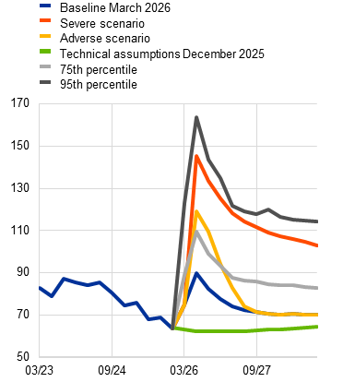 | 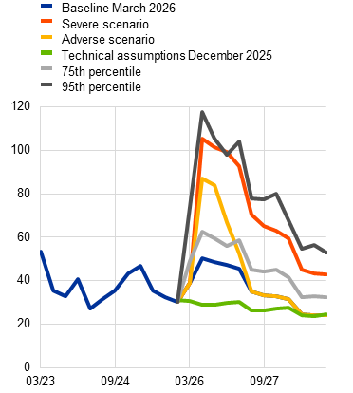
Sources: ECB and ECB calculations.
Notes: The oil price scenarios are constructed based on the elasticity of the oil price to oil supply shocks as estimated in Caldara et al. (2019), while the gas price scenarios are constructed based on the elasticity of the gas price to gas supply shocks as estimated in Albrizio et al. (2023). The 95th and 75th percentiles refer to the option-implied neutral densities for the oil and gas prices on 11 March 2026.
Table 5
Energy commodity price scenarios – levels and deviations from the baseline
Scenario |  | Q2 2026 (USD/barrel or EUR/MWh) | Q2 2026 (% deviation from baseline) | Q4 2028 (USD/barrel or EUR/MWh) | Q4 2028 (% deviation from baseline)
Adverse | Oil prices | 119 | 33% | 70 | 0%
Adverse | Gas prices | 87 | 73% | 24 | 0%
Severe | Oil prices | 145 | 62% | 103 | 47%
Severe | Gas prices | 106 | 109% | 43 | 77%
Sources: ECB and ECB calculations.
Notes: The oil price scenarios are constructed based on the elasticity of the oil price to oil supply shocks as estimated in Caldara et al. (2019), while the gas price scenarios are constructed based on the elasticity of the gas price to gas supply shocks as estimated in Albrizio et al. (2023).

Uncertainty
Both scenarios assume that an escalation of the war in the Middle East would increase global uncertainty and trigger a repricing in financial markets, though to varying degrees, which would weigh on private consumption, investment and trade. In the adverse scenario, the VIX index – used as a proxy for global uncertainty – increases by around 10 points as a result of the impact of the war, then gradually returns to its end-2025 levels by the third quarter of 2026 (Chart 12, panel a). Financial market volatility is therefore assumed to be temporary, reflecting the expected stabilisation in financial conditions as there is no further deterioration in the geopolitical situation and uncertainty recedes. In the severe scenario, the VIX index rises by around 14 points, broadly in line with the increase observed following the outbreak of Russia’s war against Ukraine and during past episodes of geopolitical tensions. Although volatility gradually declines thereafter, it remains elevated for a prolonged period, reflecting persistent geopolitical uncertainty and fragile market sentiment.
Chart 12
Financial market volatility and financial shocks
a) VIX index | b) Euro area financial shocks under the severe scenario
(index) | (basis points and percentage deviations from the BVAR model unconditional projection)
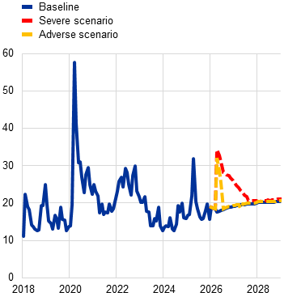 | 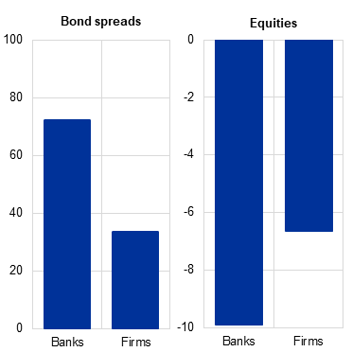
Sources: ECB, CBOE Global Markets and ECB staff calculations.
Notes: In panel a), the baseline refers to an unconditional forecasted path from a BVAR model. The model includes the VIX index, euro area GDP, private consumption, business investment, HICP inflation, and short-term interest rates. In panel b), the financial shocks are simulated using a monthly BVAR model, which also includes the VIX index, and the expected default frequencies of both banks and firms, conditioned on the path of the VIX index; it shows the peak impact for bond spreads and equities. The latest observations for the VIX index are for 11 March 2026.
In both scenarios, increased uncertainty also results in increased financing costs for banks and firms, via financial variables, bond spreads and equity prices. The spike in the VIX index would translate into significantly higher funding costs for banks and firms in the euro area. For example, in the severe scenario, bond spreads would increase, at the peak, by about 70 basis points and 35 basis points respectively for banks and firms, and then gradually narrow over the scenario horizon. Moreover, equity prices would drop by 10% for euro area banks and around 7% for euro area firms (Chart 12, panel b).

The impact on the global economy across scenarios
The impact on global economic activity and euro area foreign demand would be considerable. Even assuming a sharp drop in the domestic economic activity of countries in the Middle East, the direct impact on global GDP and euro area foreign demand would be limited owing to the small trade weights of the region. However, according to ECB-Global model simulations, more substantial dampening effects would emerge through higher oil and gas prices. Oil prices are determined in a global market, so a disruption in the Middle East raises oil prices for all countries. By contrast, gas markets are more regional: gas from the Middle East is mostly exported to Asia, which competes with the euro area for gas supplies. Therefore, higher gas prices are assumed to directly affect Asian countries, the euro area and the United Kingdom, whereas in the United States and the rest of the world, gas prices increase less as they are less directly affected.
The macroeconomic impact differs across scenarios based on the persistence of the energy and uncertainty shocks. In the adverse scenario, the spike in energy prices and global uncertainty is assumed to be temporary and to fade relatively quickly. As a result, the effects on global real economic activity and inflation are short-lived, with output declining and inflation rising in 2026 before the economy gradually recovers. By contrast, the severe scenario assumes larger and more persistent shocks, leading to weaker economic growth globally, including in the United States, over the course of 2027 and higher inflation in the short term (Chart 13, panel a). The reaction of monetary policy outside the euro area would dampen price dynamics, but with a delay. Countries more exposed to higher energy costs, particularly in Asia, would experience larger economic losses. Conversely, higher oil and gas prices would benefit energy exporters such as Norway and Canada.
Disruptions in the energy exports of countries in the Middle East would weigh on global demand and, with some delay, on euro area foreign demand. In both the adverse and severe scenarios, energy exports from countries in the Middle East would be constrained and economic activity in these countries would be disrupted. The euro area has limited non-energy trade exposure to Iran and other countries in the Middle East, and it is assumed that there are no additional non-energy supply disruptions. The higher energy prices dampen global GDP, thereby reducing demand for euro area exports, though with some delay. The increase in global uncertainty also dampens global economic activity and euro area foreign demand via lower equity prices and weaker private investment worldwide (Chart 13, panel b).
Chart 13
Impact on the United States and the global economy excluding the euro area
a) United States | b) Global economy excluding the euro area
(percentage point deviation from baseline growth rate) | (percentage point deviation from baseline growth rate)
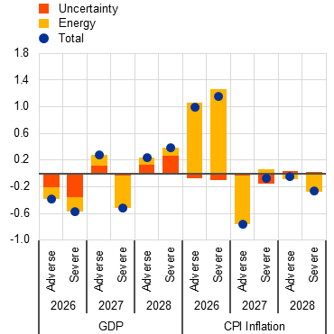 | 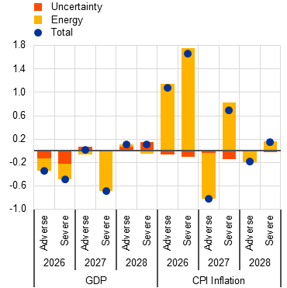
Sources: ECB and ECB calculations.
Note: Simulations are conducted under a forecast setting using the ECB-Global model with exogenous euro area monetary policy.

The impact on the euro area economy across scenarios
In the adverse scenario, the impact on the euro area economy is assumed to be temporary and part of the inflationary impacts unwind, reflecting the transitory profile of the shocks (Chart 14). These effects mainly operate through a reduction in real disposable income owing to higher energy costs, weaker external demand, and tighter financial conditions via the VIX channel affecting investment decisions. According to ECB-BASE model simulations, real GDP growth is around 0.3 percentage points lower than in the baseline in 2026 and about 0.1 percentage points lower in 2027. As energy prices and uncertainty normalise, GDP growth recovers some of the losses and stands 0.2 percentage points above the baseline in 2028. The energy shock is the main driver of the slowdown, leading especially to lower consumption. Global spillovers, which dampen euro area exports, and uncertainty, which weighs on investment, also contribute. Headline HICP inflation is 0.9 percentage points higher in 2026 owing to higher energy prices. As energy prices decline rather rapidly from high levels, headline HICP inflation is 0.1 percentage points higher in 2027 but 0.5 percentage points lower in 2028, owing to the disinflationary pressures stemming from the rapid normalisation of energy prices after 2026 in this scenario.
In the severe scenario, energy prices are assumed to have a stronger and longer-lasting effect, and are accompanied by effects of heightened uncertainty. Real GDP growth is 0.5 and 0.4 percentage points lower in 2026 and 2027 respectively, with negative quarterly growth rates in the second and third quarters of 2026 (Chart 14, panel a). While the energy shock remains the main driver, uncertainty also plays a role and amplifies the downturn, together with global spillovers. HICP inflation is 1.8 percentage points higher in 2026 and remains elevated, at 2.8 percentage points above the baseline in 2027 and 0.7 percentage points above the baseline in 2028. The effects on HICPX inflation are stronger than in the adverse scenario, by more than 1 percentage point in 2027-28.
Chart 14
Impact on the euro area by channel in the adverse and severe scenarios
a) Real GDP | b) HICP
(percentage point deviation from baseline growth rate) | (percentage point deviation from baseline growth rate)
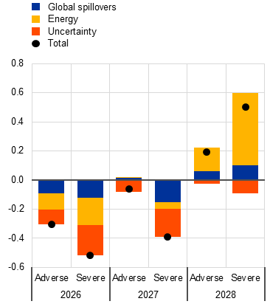 | 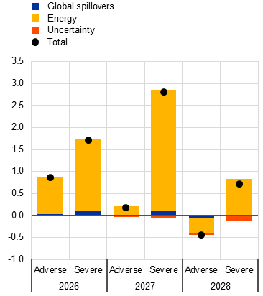
Source: ECB staff calculations based on ECB-BASE model simulations.
Note: Simulations are conducted under a forecast setting using the ECB-BASE model and the rest of the model system responds endogenously. Uncertainty also includes financial shocks in the severe scenario as described in section 3.2.2.
The scenarios incorporate stronger indirect and second-round inflation effects than those implied by standard model-based elasticities in order to account for non-linearities in the transmission of large inflationary shocks to prices and wages, such as those seen during the 2021-22 energy crisis. Historical regularities embedded in projection models such as the ECB-BASE model and the standard projection models used by national central banks in the Eurosystem typically imply a relatively limited pass-through of energy price shocks to other consumer prices. However, the experience of the 2021-22 episode of high inflation suggests there can be substantially stronger transmission across price components following abnormally large inflationary shocks. Several factors may explain why the transmission observed during that period exceeded historical regularities, including the exceptional size of the energy price shock, other potential non-linearities in price-setting behaviour during periods of high inflation, post-pandemic reopening dynamics and supply constraints across several sectors. The recalibration of certain key model parameters enables the transmission mechanisms to be strengthened compared with the standard model configuration, taking into account the significant energy price shock embedded in the adverse and severe scenarios. In particular, based on the aforementioned considerations, the model parameters governing energy price transmission to other prices and wages are adjusted so that the implied elasticities lie between the baseline model calibration and the higher elasticities observed during the recent inflation surge.
Chart 15
The outlook for key euro area variables under the baseline and alternative scenarios
a) GDP | b) Unemployment
(quarter-on-quarter percentage changes, seasonally and working day-adjusted quarterly data) | (percentage of the labour force)
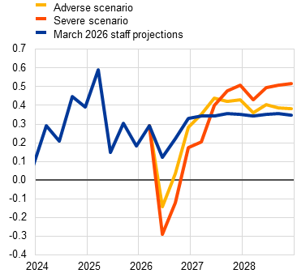 | 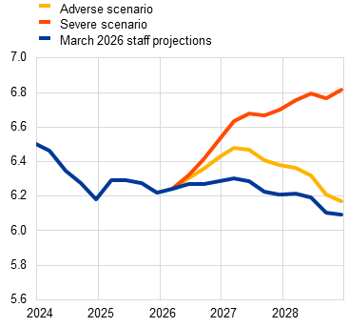
c) HICP | d) HICP - excluding energy and food
(annual percentage changes) | (annual percentage changes)
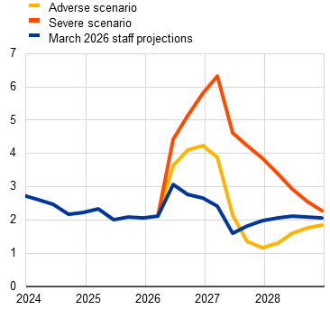 | 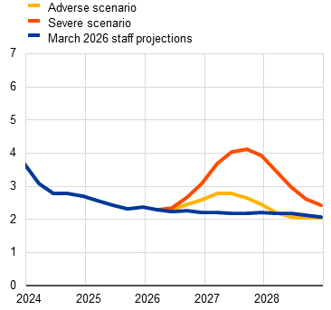
e) HICP energy | f) Compensation per employee
(annual percentage changes) | (annual percentage changes)
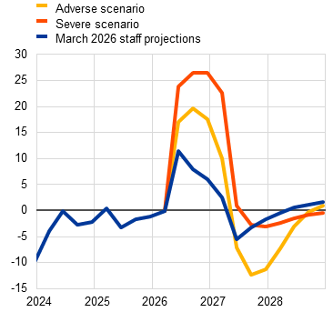 | 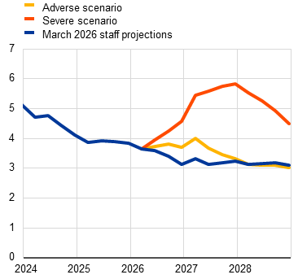
Source: ECB staff calculations based on ECB-BASE model simulations.
Stronger transmission mechanisms not only increase the initial inflation response but also imply more persistent price dynamics over the projection horizon. While the direct energy price shock is the primary driver of the short-term increase in inflation, stronger pass-through to food prices and the presence of second-round mechanisms contribute to more sustained inflationary pressures in the second and third year of the projection horizon. Without these amplification mechanisms, the inflation response would be more limited both initially – owing to weaker pass-through – and in later years, as base effects from declining energy prices would lead to a faster drop in inflation. By contrast, stronger food price reactions and indirect and second-round effects raise HICPX price inflation pressures and generate a more persistent increase in headline inflation, also as the increase in wage growth is protracted. On the real side, stronger pass-through initially leads to a larger decline in GDP growth as higher energy and food prices reduce households’ real incomes and weigh on consumption, in part via higher unemployment. In later years, however, stronger wage growth would provide some support to household incomes and consumption, moderating the negative effects on GDP growth. In addition, higher inflation expectations would reduce real interest rates, which would also support investment in the later years of the projection horizon.

Caveats to the scenario analysis
These scenario analyses do not include any monetary or fiscal policy responses, which would mitigate the inflation impacts, as well as other channels that could affect the macroeconomic impact. As is the standard convention for scenario analyses in the staff projections, the scenarios assume monetary and fiscal policy are unchanged compared with the baseline. The significant increases in inflation, especially under the severe scenario, would likely be partly offset by tighter monetary policy or fiscal support measures which could lower consumer energy prices – as was seen in the 2022-23 episode of high inflation. Other channels not explicitly included in the analyses comprise disruptions to non-energy trade via supply constraints; non-energy commodity price effects such as on fertiliser or aluminium prices; possible positive impacts on tourism in euro area countries which could benefit from tourism that would otherwise have flowed to the Middle East; and effects stemming from migration pressures related to a potential refugee crisis.

Sensitivity analyses

Alternative energy price paths
Alternative paths for energy commodity prices suggest significant upside risks for inflation in the baseline projections, especially in the short term. The baseline projections are based on the technical assumptions outlined in Box 2. Given the high uncertainty surrounding energy prices on account of the ongoing war in the Middle East, in addition to the 25th and 75th percentiles usually applied, this sensitivity analysis also considers alternative upside and downside paths derived from the 5th and 95th percentiles of the option-implied neutral densities for both oil and gas prices. Option-implied densities indicate that short-term risks to oil prices are strongly skewed to the upside. This reflects investors’ concerns that oil flows through the Strait of Hormuz, which account for around 20% of global supply and are already being disrupted, could be impeded over a prolonged period, with limited possibilities for rerouting shipments in the short term (Chart 16). In such a situation, oil production itself could eventually be scaled back owing to insufficient storage capacity. In addition, market participants are also concerned that military strikes could damage regional oil production capacity, with more persistent effects. By contrast, risk perceptions over longer horizons remain slightly more balanced, which may suggest that investors expect the conflict to remain contained. Option-implied densities also point to elevated upside risks for gas prices, given that around 20% of global LNG flows transit through the Strait of Hormuz. In percentage terms relative to the baseline, upside risks to gas prices appear to be more pronounced than for oil prices, reflecting the current historically low level of European gas inventories. A constant price sensitivity analysis is also carried out for both oil and gas prices. In each case, a synthetic energy price index (a weighted average of the oil and gas price paths) is computed and the impacts are assessed using ECB and Eurosystem macroeconomic models. The average results across these models are shown in Table 6. These results are based on the models run in standard projection modes and exclude any enhanced elasticities relating to indirect and second-round effects, which are included in the Middle East scenarios presented in Section 3.
Chart 16
Alternative paths for energy price assumptions
a) Oil price assumption
(USD/barrel)
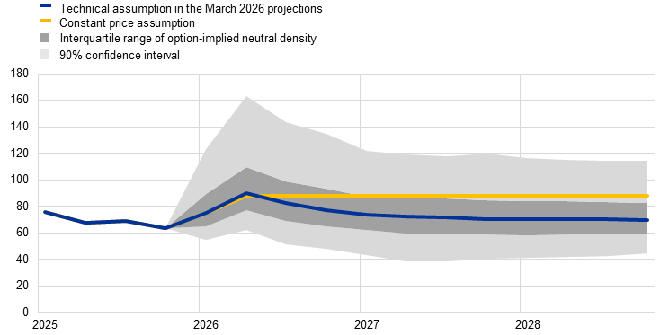
b) Gas price assumption
(EUR/MWh)
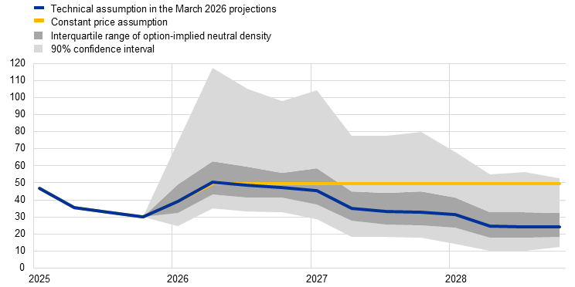
Sources: Morning star and ECB calculations.
Note: The option-implied densities of gas and oil prices are extracted from 11 March 2026 market quotes for options on ICE Brent crude oil and Dutch TTF natural gas futures with fixed quarterly expiry dates.

Table 6
Alternative energy price paths and their impact on real GDP growth and HICP inflation
(deviations from baseline levels, percentages; deviations from baseline growth rates, percentage points)
 |  | Oil prices | Gas prices | Synthetic energy price index | Real GDP growth | HICP inflation
Path 1: 5th percentile | 2026 | -33.3 | -32.1 | -32.5 | 0.0 | -1.0
Path 1: 5th percentile | 2027 | -44.3 | -43.6 | -44.1 | 0.6 | -1.2
Path 1: 5th percentile | 2028 | -39.3 | -55.1 | -44.1 | 0.5 | -0.6
Path 2: 25th percentile | 2026 | -14.9 | -14.7 | -14.7 | 0.0 | -0.4
Path 2: 25th percentile | 2027 | -16.9 | -21.2 | -18.3 | 0.3 | -0.4
Path 2: 25th percentile | 2028 | -15.9 | -25.4 | -18.6 | 0.2 | -0.2
Path 3: 75th percentile | 2026 | 20.2 | 22.3 | 21.2 | 0.0 | 0.6
Path 3: 75th percentile | 2027 | 19.2 | 31.7 | 23.5 | -0.3 | 0.5
Path 3: 75th percentile | 2028 | 18.9 | 33.6 | 23.1 | -0.2 | 0.3
Path 4: 95th percentile | 2026 | 73.9 | 113.0 | 87.9 | -0.1 | 2.2
Path 4: 95th percentile | 2027 | 65.9 | 131.7 | 88.2 | -1.1 | 1.8
Path 4: 95th percentile | 2028 | 64.1 | 122.4 | 80.5 | -0.9 | 0.9
Path 5: constant prices | 2026 | 4.2 | 1.1 | 3.1 | -0.2 | 0.1
Path 5: constant prices | 2027 | 21.8 | 35.3 | 26.5 | -0.3 | 0.7
Path 5: constant prices | 2028 | 25.1 | 89.9 | 43.2 | -0.3 | 0.8
Notes: In this sensitivity analysis, a synthetic energy price index that combines oil and gas futures prices is used. The various percentiles refer to the option-implied neutral densities for the oil and gas prices on 11 March 2026. The constant oil and gas prices take the respective value as at the same date. The macroeconomic impacts are reported as averages of a number of ECB and Eurosystem staff macroeconomic models. In some models, the large inflation response to an energy price increase leads, under the assumption of an unchanged monetary policy (compared with the baseline assumptions based on market expectations for interest rates), to a sizeable decline in real interest rates and a temporary expansionary demand effect, which attenuate the average GDP response in the short run.

Alternative exchange rate paths
Alternative paths for the exchange rate suggest the possibility of a further appreciation of the euro, especially over the medium term, and hence indicate some downside risks to growth and inflation. The technical assumptions for exchange rates in the baseline projections are held constant over the projection horizon. Alternative upside and downside paths are derived from the 25th and 75th percentiles of option-implied neutral densities for the USD/EUR exchange rate on 11 March 2026, which was tilted towards a modest appreciation of the euro (Chart 17). The impacts of these alternative paths are assessed using ECB and Eurosystem staff macroeconomic models. Table 7 shows the average impact on output growth and inflation across the models.
Chart 17
Alternative paths for the USD/EUR exchange rate
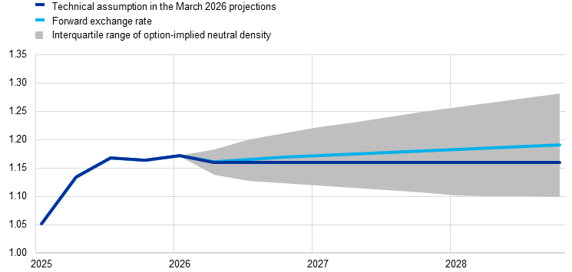
Sources: Bloomberg and ECB staff calculations.
Notes: An increase implies an appreciation of the euro. The 25th and 75th percentiles refer to the option-implied densities for the USD/EUR exchange rate on 11 March 2026.
Table 7
Impact of alternative exchange rate paths on real GDP growth and HICP inflation
 | Path 1: 25th percentile |  |  | Path 2: 75th percentile
 | 2026 | 2027 | 2028 | 2026 | 2027 | 2028
USD/EUR exchange rate | 1.14 | 1.11 | 1.10 | 1.19 | 1.24 | 1.27
USD/EUR exchange rate (% deviation from baseline) | -1.9 | -4.0 | -5.1 | 2.5 | 6.5 | 9.5
(deviations from baseline growth rates, percentage points)
Real GDP growth | 0.0 | 0.1 | 0.1 | -0.1 | -0.2 | -0.2
HICP inflation | 0.0 | 0.1 | 0.1 | -0.1 | -0.2 | -0.3
Sources: Bloomberg and ECB staff calculations.
Notes: An increase implies an appreciation of the euro. The 25th and 75th percentiles refer to the option-implied neutral densities for the USD/EUR exchange rate on 11 March 2026. The macroeconomic impacts are reported as averages of a number of ECB and Eurosystem staff macroeconomic models.

© European Central Bank, 2026
Postal address 60640 Frankfurt am Main, Germany
Telephone +49 69 1344 0
Website www.ecb.europa.eu
All rights reserved. Reproduction for educational and non-commercial purposes is permitted provided that the source is acknowledged.
For specific terminology please refer to the ECB glossary (available in English only).
PDF ISBN 978-92-899-7781-4, ISSN 2529-4466, doi:10.2866/8488267, QB-01-26-090-EN-N
HTML ISBN 978-92-899-7780-7, ISSN 2529-4466, doi:10.2866/0204813, QB-01-26-090-EN-Q

The cut-off date for the technical assumptions of 11 March 2026 was two days before the finalisation of the projections, which is unusually close to the Governing Council’s monetary policy meeting, given the extraordinary geopolitical developments and the need to include information on the rapidly evolving situation. These assumptions are based on the average of market data over the three days up to the cut-off date. This is a narrower window than the ten days usually used for the staff projections and means that only data after the outbreak of the war in the Middle East were considered. The projections for the international environment were finalised on 11 March and those for the euro area were finalised on 13 March 2026. Owing to the limited time available to finalise the projections, it was not possible to produce some of the detailed variables usually reported in the projections.
The ECB staff projections are produced in an iterative way. They are updated and refined as new information becomes available. The baseline refers to the final March 2026 projections which use technical assumptions with a cut-off date 11 March. Projections with a cut-off date 4 March refer to the previous iteration of the ECB staff projections produced in the early stages of the war. They are included in Table 1 to give an indication of a more benign outlook in which oil and gas prices would decline more quickly than in the final baseline.
“Modified domestic demand” includes private and government consumption and a modified measure of investment that excludes purchases of aircraft for leasing and certain intellectual property purchases. Irish imports, exports and changes in inventories are excluded from this measure. For more information see the website of Ireland’s Central Statistics Office.
The impact on inflation included in the baseline is estimated to be below 0.1 percentage points cumulatively over 2025-28.
Unless explicitly mentioned, references to world and/or global aggregates of economic indicators throughout this box exclude the euro area.
World headline CPI inflation is computed as the weighted average of inflation rates across 23 countries, comprising 14 advanced economies (namely the United States, the United Kingdom, Japan, Switzerland, Canada, Australia, New Zealand, Sweden, Denmark, Norway, the Czech Republic, Hungary, Poland and Romania) and nine emerging market economies (China, Russia, Brazil, India, Türkiye, Korea, Mexico, Singapore and Hong Kong).
Although minor categories, several euro area products (e.g. electronic circuits, recorded and print media, some chemicals, etc.) that were supposed to be exempt now face tariffs under the new regime.
The recent EU-India trade agreement, involving a gradual phasing-in of lower tariffs, and the still pending EU-Mercosur agreement are considered to have only limited effects on euro area activity over the projection horizon.
In particular, refining margins for diesel have increased significantly since 27 February owing to the war in the Middle East and are assumed to decline over the short term. The pace and extent of this normalisation entail significant additional uncertainties for the short-term outlook for energy inflation.
See the box entitled “The macroeconomic impact of climate change policies in the euro area” in the December 2025 Eurosystem staff macroeconomic projections for the euro area.
The fiscal projections are based on the set of projections finalised with a cut-off date of 4 March 2026.
The fiscal stance of the euro area is defined as the change in the cyclically adjusted primary balance, further adjusted for NGEU grants on the revenue side. While the fiscal stance is a top-down measure of the orientation of fiscal policy, discretionary fiscal measures are gauged using a bottom-up approach. These measures capture changes in tax rates, fiscal entitlements and other government spending that have been passed or are likely to be passed by the national parliaments of euro area countries.
Prepared by E. Angelini, A. Bobasu, G. Bušs, A. Dieppe, P. Di Casola, A. Kornprobst, G. Nicoletti, A. Stalla-Bourdillon, T. Kockerols and S. Zimic, with input from N. Rebmann and L. Demuth.
Part of the impact of the supply shock on oil prices in the adverse and severe scenarios is mitigated by the assumption that a share of the oil flows from Saudi Arabia and the United Arab Emirates can be rerouted through existing pipeline infrastructure.
In order to estimate the impact of uncertainty on euro area real GDP, conditional forecast simulations have been conducted using an empirical BVAR model, based on the paths of financial market uncertainty contained in the two scenarios. The effects on real GDP are obtained relative to an unconditional forecast simulation within the same empirical framework.
To quantify these effects, the path of the VIX index in the respective scenario is used to condition a BVAR model, which includes key euro area financial variables, allowing their trajectories to be derived in a scenario-consistent manner.
The Middle East accounts for around 4.5% of euro area exports.
The elasticities observed during the 2021-22 episode of high inflation implied stronger transmission of energy price shocks to consumer prices than those captured within standard projection models. Interpreting peak price responses as indicative elasticities suggests transmission of around 35% from a synthetic energy commodity price index (which is a weighted average of the oil and gas prices) to HICP energy, around 25% to HICP food, around 10% to HICPX, and around 13% to headline HICP. Focusing on headline HICP, the recalibrated scenarios anchor the transmission as a fraction of the observed episode. In the adverse scenario, the recalibration sets the pass-through to the HICP at around one-third of the observed elasticity in 2021-22, while in the severe scenario it increases to around two-thirds.
Indirect and second-round effects are captured through three mechanisms: (i) stronger pass-through from energy prices to HICPX inflation in the Phillips curve, reflecting higher marginal cost pressures; (ii) increased wage indexation leading to stronger nominal wage growth; and (iii) more responsive long-term inflation expectations to developments in HICP inflation.
The market prices used are those prevailing on 11 March 2026 (the cut-off date for the technical assumptions).

